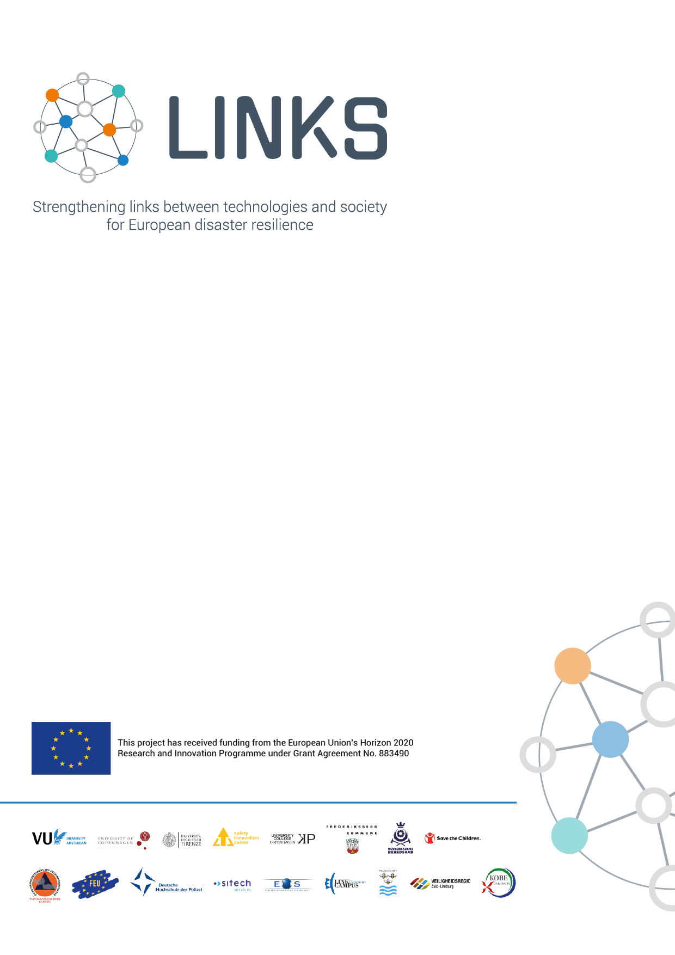

Ethics Assessment – Research Activity Evaluation Form

March 2021

document information
KEYWORDS
Ethics, self-assessment

AUTHORS & CONTRIBUTORS
Author | Institution | Authored Sections
Sara Bonati | UNIFI | Entire Document
Stefano Morelli | UNIFI | Entire Document

REVIEWS
Reviewer | Institution | Reviewed Sections
Kees Boersma | VU | Entire Document
Nina Blom Andersen | UCC | Entire Document
Francesco Graziani | SCIT | Entire Document
Therese Habig | SIC | Entire Document
Katrina Petersen | Trilateral Research | Entire Document
Nathan Clark | VU | Entire Document

VERSION HISTORY
Release | Status | Date
0.1 | Initial Draft | 15 December 2020
0.2 | Internal Review | 17 February 2021
0.3 | Second Draft | 1 March 2021
1.0 | Final Version | 1 March 2021

DISCLAIMER
Responsibility of this publication lies entirely with the author. The European Commission is not responsible for any use that may be made of the information contained therein.

executive summary
About the project
LINKS “Strengthening links between technologies and society for European disaster resilience” is a comprehensive study on disaster governance in Europe. In recent years, social media and crowdsourcing (SMCS) have been integrated into crisis management for improved information gathering and collaboration across European communities. The effectiveness of SMCS on European disaster resilience, however, remains unclear, the use of SMCS in disasters in different ways and under diverse conditions. In this context, the overall objective of LINKS is to strengthen links between technologies and society for improved European disaster resilience, by producing sustainable advanced learning on the use of SMCS in disasters. This is done across three complementary knowledge domains:
- Disaster Risk Perception and Vulnerability (DRPV)
- Disaster Management Processes (DMP)
- Disaster Community Technologies (DCT)
Bringing together 15 partners and 2 associated partners across Europe (Belgium, Denmark, Germany, Italy, Luxembourg, the Netherlands) and beyond (Bosnia & Herzegovina, Japan), the project will develop a framework to understand, measure and govern SMCS for disasters. The LINKS Framework consists of learning materials, such as scientific methods, practical tools, and guidelines, addressing different groups of stakeholders (e.g. researchers, practitioners, and policy makers). It will be developed and evaluated through five practitioner-driven European cases, representing different disaster scenarios (earthquakes, flooding, industrial hazards, terrorism, drought), cutting across disaster management phases and diverse socioeconomic and cultural settings in four countries (Denmark, Germany, Italy, the Netherlands). Furthermore, LINKS sets out to create the LINKS Community, which brings together a wide variety of stakeholders, including first-responders, public authorities, civil society organisations, business communities, citizens, and researchers across Europe, dedicated to improving European disaster resilience through the use of SMCS.
About this deliverable
This document provides an evaluation form for the ethics self-assessment of the research activities conducted by partners. It serves the purpose of identifying potential ethical impacts of the activities and evaluate the planned mitigation strategies. It will be reviewed by the LINKS Ethics Advisory Board (EAB), and feedback will be provided to research partners as needed.
table of contents

1. Introduction and General Instructions I
2. Evaluation Form 2
3. Additional information 12

- Introduction and General Instructions
This document provides an evaluation form for the ethics self-assessment of the research activities conducted by partners. A self-assessment of the research activities should be conducted by partners with the aim of identifying potential ethical impacts of the activities and evaluate the planned mitigation strategies. The form should be completed by all WPLs/TLs who lead a research activity and delivered to the EAB at the following email addresses: sara.bonati@unifi.it and n.e.clark@vu.nl at least 1 month before research activities take place (different deadlines can be agreed with EAB if needed). In the case of several partners participating in a common research activity, only one document has to be delivered by the principal investigator/partner responsible for the research (WPL or TL). The repetition of the research activity in different periods involves the repetition of the module filling (due to the variability of the context conditions) if not included as a temporal necessary extension far beyond what was originally planned (to be agreed with EAB). A substantial change of activities always requires the delivery of a new document. The self-assessment is aimed to support and address ethically appropriate research in line with the Ethics and Societal Impact Strategy (D1.5) adopted by the project. It should be used to help the principal investigator to prepare the research activity. This process is not aimed at authorizing or blocking research, and therefore feedback on the evaluations will only be given by the EAB when deemed necessary. The planned research should have already obtained approval according to the roles of the country in which it takes place, and the EAB cannot replace the national authorization procedures. Two ethics strategy reports about the ethical standards in LINKS project will be delivered as planned by the Grant Agreement. Nothing confidential or any personal information you provide within these evaluations will be included in the final reports to the REA.

NB: It is not necessary to fill in all fields if they are out of context in some specific cases (but please briefly justify the lack of insertion). However, in addressing the various ethical issues, it is mandatory to highlight the potential ethical problem that requires mitigation or prevention measures.

- Evaluation Form
Period of the research | Expected start date:  Expected finish date: | ……………………………………………………………………………………………………………………  ……………………………………………………………………………………………………………………

ETHICS ISSUES | QUESTIONS | ANSWERS
1. Responsibility/ accountability | Principal investigator responsible for overseeing the research, for monitoring this ethics evaluation, and for updating the evaluation as needed should the research plans change (name, surname, and organization): | ……………………………………………………………………………………………………………………  ……………………………………………………………………………………………………………………  ……………………………………………………………………………………………………………………
 | Personnel involved in the research and with access to data (name, surname, organization, role):  (Specify when possible the role of the different employed personnel, e.g., who will collect surveys, anonymize data, etc.) | ……………………………………………………………………………………………………………………  ……………………………………………………………………………………………………………………  ……………………………………………………………………………………………………………………  ……………………………………………………………………………………………………………………
 | Other partners involved and their role: | ……………………………………………………………………………………………………………………  ……………………………………………………………………………………………………………………  ……………………………………………………………………………………………………………………
 | Management of external constraints for the research by subjects interested in some way:  (Research is free or requires legal authorization?  Which kind of authorization is necessary?  Do you need authorization from an entity, institution, guardians or privates?  Do you have the requirements to obtain it?  Have you requested/obtained the authorization?) | ……………………………………………………………………………………………………………………  ……………………………………………………………………………………………………………………  ……………………………………………………………………………………………………………………  ……………………………………………………………………………………………………………………  ……………………………………………………………………………………………………………………  …………………………………………………………………………………………………………………………………………………………………………………………………………………………………………  ……………………………………………………………………………………………………………………
2. Research procedures | Objectives of the research (brief description): | ……………………………………………………………………………………………………………………  ……………………………………………………………………………………………………………………  ……………………………………………………………………………………………………………………  ……………………………………………………………………………………………………………………
 | Methodology (for all working practice ex. survey, interview, focus group): | ……………………………………………………………………………………………………………………  ……………………………………………………………………………………………………………………  ……………………………………………………………………………………………………………………  ……………………………………………………………………………………………………………………
 | Potential risks and mitigation strategies (for activities and/or outputs):  What could be the potential unexpected situations that I could meet?  E.g. Are there potential risks for participants?  Have I envisioned prevention/mitigation actions? | ……………………………………………………………………………………………………………………  ……………………………………………………………………………………………………………………  ……………………………………………………………………………………………………………………  ……………………………………………………………………………………………………………………  …………………………………………………………………………………………………………………………………………………………………………………………………………………………………………  ……………………………………………………………………………………………………………………  ……………………………………………………………………………………………………………………  ……………………………………………………………………………………………………………………  ……………………………………………………………………………………………………………………
3. Justice/ participation | Typology and expected number of participants:  Who will be involved in the research as participants (which social groups, number of people)? | ……………………………………………………………………………………………………………………  ……………………………………………………………………………………………………………………  ……………………………………………………………………………………………………………………  ……………………………………………………………………………………………………………………
 | Vulnerable participants involved:  (physical and social vulnerabilities, situational vulnerabilities, personal difficulties)  (For vulnerable participants, see the definition provided in the Ethics and Societal Impact Strategy D1.5)  Do vulnerable participants have special needs:  How you plan to address them:  (How do you plan to deal with/prevent or mitigate stress for participants caused by previous personal traumatic experiences?) | ……………………………………………………………………………………………………………………  ……………………………………………………………………………………………………………………  ……………………………………………………………………………………………………………………  …………………………………………………………………………………………………………………………………………………………………………………………………………………………………………  ……………………………………………………………………………………………………………………  ……………………………………………………………………………………………………………………  …………………………………………………………………………………………………………………………………………………………………………………………………………………………………………  ……………………………………………………………………………………………………………………  ……………………………………………………………………………………………………………………
 | Procedure to recruit participants:  How have participants been selected and has the diversity principle (see D1.5) has been followed, and if not why etc.)? | ……………………………………………………………………………………………………………………  ……………………………………………………………………………………………………………………  ……………………………………………………………………………………………………………………
 | Strategy for diversity awareness management:  How/Why is it possible to consider a representative and appropriate diversity of participants for the objectives and outputs? Does it make sense for the planned research activity? Have you planned specific action for promoting diversity in research? | ……………………………………………………………………………………………………………………  ……………………………………………………………………………………………………………………  ……………………………………………………………………………………………………………………
 | Strategy to overcome a poor representativeness in participation (necessary remedial actions):  What conditions could prevent participation? | ……………………………………………………………………………………………………………………  ……………………………………………………………………………………………………………………  ……………………………………………………………………………………………………………………  ……………………………………………………………………………………………………………………
 | Expected benefits for participants taking part in the research activity: | ……………………………………………………………………………………………………………………  ……………………………………………………………………………………………………………………  ……………………………………………………………………………………………………………………  ……………………………………………………………………………………………………………………
4. Freedom of choice/autonomy | Potential situations of coercion, deception and manipulation that could occur and how you think to solve conflicts of interests among participants and the researchers or collaborators:  (Will participants have full freedom of choice or could they be subject to compromise? meaning, e.g., freedom of expression, right to private life and privacy, etc.) | ……………………………………………………………………………………………………………………  ……………………………………………………………………………………………………………………  ……………………………………………………………………………………………………………………  ……………………………………………………………………………………………………………………  ……………………………………………………………………………………………………………………  ……………………………………………………………………………………………………………………  ……………………………………………………………………………………………………………………
 | Procedure in case a person decides to leave the research: | ……………………………………………………………………………………………………………………  ……………………………………………………………………………………………………………………  ……………………………………………………………………………………………………………………  ……………………………………………………………………………………………………………………  ……………………………………………………………………………………………………………………  ……………………………………………………………………………………………………………………  ……………………………………………………………………………………………………………………
5. Trust/ transparency | Procedure to provide the information sheet to participants and to collect informed consent:  In case you adopt participant observation, explain how you will guarantee transparency with participants:  (Which kinds of information will be provided to participants?) | ……………………………………………………………………………………………………………………  ……………………………………………………………………………………………………………………  ……………………………………………………………………………………………………………………  ……………………………………………………………………………………………………………………  ……………………………………………………………………………………………………………………  ……………………………………………………………………………………………………………………  ……………………………………………………………………………………………………………………  ……………………………………………………………………………………………………………………  ……………………………………………………………………………………………………………………  ……………………………………………………………………………………………………………………  ……………………………………………………………………………………………………………………  ……………………………………………………………………………………………………………………
6. Environment | Accessibility issues you identified in the place of research:  Are there any risks linked to the place (digital or physical environment) where the research will take place? | ……………………………………………………………………………………………………………………  ……………………………………………………………………………………………………………………  ……………………………………………………………………………………………………………………  ……………………………………………………………………………………………………………………  ……………………………………………………………………………………………………………………
 | Mitigation strategies for potential accessibility issues: | ……………………………………………………………………………………………………………………  ……………………………………………………………………………………………………………………  ……………………………………………………………………………………………………………………  ……………………………………………………………………………………………………………………  ……………………………………………………………………………………………………………………
7. Data collection and processing | Kinds of personal data collection  What is the level of the requested information? (are sensitive data required? Why? Is this necessary? With which purposes and for which use?) | ……………………………………………………………………………………………………………………  ……………………………………………………………………………………………………………………  ……………………………………………………………………………………………………………………  ……………………………………………………………………………………………………………………  ……………………………………………………………………………………………………………………  ……………………………………………………………………………………………………………………
 | Data management  How data will be processed and stored? | ……………………………………………………………………………………………………………………  ……………………………………………………………………………………………………………………  ……………………………………………………………………………………………………………………  ……………………………………………………………………………………………………………………  ……………………………………………………………………………………………………………………  ……………………………………………………………………………………………………………………
 | Processes of pseudonymisation or anonymisation:  How will the process of anonymisation/pseudonymisation take place? | ……………………………………………………………………………………………………………………  ……………………………………………………………………………………………………………………  ……………………………………………………………………………………………………………………  ……………………………………………………………………………………………………………………  ……………………………………………………………………………………………………………………  ……………………………………………………………………………………………………………………
 | Sharing of data with other partners/countries:  Who will data be shared with? | ……………………………………………………………………………………………………………………  ……………………………………………………………………………………………………………………  ……………………………………………………………………………………………………………………  ……………………………………………………………………………………………………………………  ……………………………………………………………………………………………………………………

- Additional information
Please include any additional information or remarks which should be highlighted in relation the ethical considerations for the research activity, which were not captured in the above form.

